STOCK MARKET ANALYSIS & ADVISORY

**A PROJECT REPORT**

***Submitted by***

# HARDIK RAWAT (22BAI10112) KAMMARA BHASKAR CHARI (22BAI10155)

**YUVRAJ SINGH(22BAI10195)**

# YASH AGGARWAL(22BAI10203)

*in partial fulfillment for the award of the degree of*

# BACHELOR OF TECHNOLOGY

*in*

**ARTIFICIAL INTELLIGENCE AND MACHINE LEARNING**



**SCHOOL OF COMPUTING SCIENCE AND ENGINEERING VIT BHOPAL UNIVERSITY**

**KOTHRI KALAN, SEHORE MADHYA PRADESH - 466114**

May 2024

VIT BHOPAL UNIVERSITY, KOTHRI KALAN, SEHORE MADHYA PRADESH – 466114

# BONAFIDE CERTIFICATE

Certified that this project report titled **“STOCK MARKET ANALYSIS & ADVISORY'' is** the bonafide work of “**HARDIK RAWAT (22BAI10112), KAMMARA BHASKAR CHARI (22BAI10155), YUVRAJ SINGH (22BAI10195), YASH AGGARWAL (22BAI10203)”**

who carried out the project work under my supervision. Certified further that to the best of my knowledge, the work reported here does not form part of any other project/research work based on which a degree or award was conferred on an earlier occasion on this or any other candidate.

**PROJECT SUPERVISOR**

Dr. S.Periyanayagi, Associate Professor School of Computer Science and Engineering VIT BHOPAL UNIVERSITY

The Project Exhibition II Examination is held on

# ACKNOWLEDGEMENT

First and foremost I would like to thank the Lord Almighty for His presence and immense blessings throughout the project work.

I wish to express my heartfelt gratitude to Dr. S.Poonkuntran, Head of the Department, School of Computer Science for much of his valuable support and encouragement in carrying out this work.

I would like to thank my internal guide Dr. S.Periyanayagi, for continually guiding and actively participating in my project, giving valuable suggestions to complete the project work.

I would like to thank all the technical and teaching staff of the School of Computer Science, who extended directly or indirectly all support.

Last, but not the least, I am deeply indebted to my parents who have been the greatest support while I worked day and night for the project to make it a success.

# TABLE OF CONTENTS

|  |  |  |
| --- | --- | --- |
| **CHAPTER NO.** | **TITLE** | **PAGE NO.** |
|  | List of Abbreviations | 6 |
| List of Figures | 7 |
| List of Tables | 8 |
| Abstract | 9 |
| 1 | **INTRODUCTION** |  |
|  | 1.1 Introduction | 10 |
|  | 1.2 Motivation for the work |  |
|  | 1.3 About the project |  |
|  |  | . |
|  | 1.4 Problem Statement |  |
|  | 1.5 Objective of the work | . |
|  | 1.6 Organization of the thesis | . |
|  | 1.7 Summary |  |

|  |  |  |
| --- | --- | --- |
| 2 | **LITERATURE SURVEY**   * 1. Introduction   2. Core area of the project   3. Existing Algorithms      1. KNN      2. ARIMA      3. Linear Regression   4. Methods Used in the Project   5. Research issues/observations from literature Survey   6. Summary | 13 |
| 3 | **SYSTEM ANALYSIS**   * 1. Introduction   2. Disadvantages/Limitations in the existing system   3. Proposed System   4. System Architecture   5. Summary | 17 |

|  |  |  |
| --- | --- | --- |
| 4 | **SYSTEM DESIGN AND IMPLEMENTATION**   * 1. Introduction   2. Data Acquisition and Preprocessing   3. Leveraging Prediction Algorithms and Models   4. Development of the Advisory System   5. Summary | 19 |
| 5 | **PERFORMANCE ANALYSIS**   * 1. Introduction   2. Performance Analysis (Graphs/Charts)   3. Summary | 22 |
| 6 | **CONCLUSION AND FUTURE ENHANCEMENT**  6.1 Conclusions  6.2 Limitation/Constraints of the System  6.3 Future Enhancements | 28 |
|  | References | 30 |

**LIST OF ABBREVIATIONS**

|  |  |  |
| --- | --- | --- |
| KNN | - | K-Nearest neighbors |
| ARIMA | - | Autoregressive integrated moving average |
| LSTM | - | Long Short-Term Memory |
| LR | - | Linear Regression |
| AAPL | - | Apple Inc |
| AMZN | - | Amazon.com |
| TCS | - | Tata Consultancy Services |
| NVDA | - | Nvidia Corporation |
| WIT | - | Wipro Limited |
| YESBANK.BO | - | Yes bank |

# LIST OF FIGURES

|  |  |  |
| --- | --- | --- |
| **FIGURE No.** | **TITLE** | **PAGE No.** |
| 1 | Example on how bot will send notification | 1 |
| 2 | Flow chart of the working of the algorithm | 20 |
| 3 | Source code snip | 23 |
| 4 | Source code snip | 24 |
| 5 | Predicted graph for next 30 days | 25 |
| 6 | Full dataset + Predicted values | 26 |
| 7 | Accuracy Graph | 26 |
| 8 | Time Series data with range-slider | 27 |
| 9 | Forecasted data | 27 |
| 10 | Flowchart | 29 |

# ABSTRACT

The dynamic nature of the stock market necessitates a keen understanding of the forces that drive prices and influence investment decisions. This project, titled "Stock Market Analysis & Advisory," tackles this challenge by providing investors with a comprehensive toolkit for navigating this complex financial environment.

The cornerstone of the project lies in the utilization of a multi-pronged analytical approach. Fundamental analysis meticulously dissects a company's financial well-being, meticulously evaluating its financial statements to assess profitability, growth potential, and competitive edge. This approach empowers investors to identify companies with strong fundamentals poised for long-term success.

Technical analysis, another pillar of the project, delves into the realm of historical price data and chart patterns. By employing sophisticated statistical methods and technical indicators, the project seeks to uncover potential trading opportunities and predict future price movements with a higher degree of accuracy.

However, the project recognizes that the market is not solely driven by cold, hard numbers. Investor sentiment and psychology play a significant role in influencing market trends. To address this, sentiment analysis is incorporated, gauging the collective mood of the market through news feeds, social media, and other relevant data resources

**CHAPTER 1**

**INTRODUCTION**

**Introduction**

The stock market serves as a lifeblood for global economic growth, channeling capital from investors to businesses. However, its inherent volatility can be daunting for those seeking to navigate its complexities. To make informed investment decisions and potentially generate financial returns, a thorough understanding of the factors influencing stock prices is crucial.

Machine learning is a field of artificial intelligence (AI) that empowers computers to learn from data and improve their performance on specific tasks without being explicitly programmed. Instead of relying on predefined rules or instructions, machine learning algorithms leverage statistical techniques to analyze vast amounts of data, identify patterns, and make predictions or decisions. Long Short-Term Memory (LSTM) is a type of recurrent neural network (RNN) architecture. It can learn long-term dependencies and is often used for sequential data tasks like time series forecasting.

The LSTM algorithm involves several steps:

**Input Gate**: Determines which information from the input is important and should be stored in the cell state.

**Forget Gate**: Decides what information should be discarded from the cell state.

**Cell State Update**: Updates the cell state based on the input and forget gates, incorporating new information.

**Output Gate**: Determines which information from the cell state should be output to the next time step.

The dense layer algorithm involves matrix multiplication of the input data with the layer's weights, followed by the addition of biases and the application of an activation function. Here are the steps:

**Input**: Receive input data 𝑋X of shape (𝑚,𝑛)(m,n), where 𝑚m is the number of samples and 𝑛n is the number of features.

**Weights Initialization**: Initialize weights 𝑊W of shape (𝑛,𝑘)(n,k), where 𝑘k is the number of neurons in the dense layer.

Biases Initialization: Initialize biases 𝑏b of shape (1,𝑘)(1,k), where 𝑘k is the number of neurons in the dense layer.

**Matrix Multiplication**: Compute the dot product of the input data 𝑋X and the weights 𝑊W to obtain the pre-activation values: 𝑍=𝑋⋅𝑊+𝑏Z=X⋅W+b

**Activation Function**: Apply an activation function 𝜎σ element-wise to the pre-activation values 𝑍Z to obtain the output of the dense layer: 𝐴=𝜎(𝑍)A=σ(Z)

**Output**: The output of the dense layer 𝐴A is passed to the next layer in the neural network.

Top of Form

## Motivation for the Work

The impetus for this project stems from the ever-present need for robust and accessible tools to empower investors in the dynamic stock market. The abundance of financial data can be overwhelming, and interpreting it effectively requires a multifaceted approach. By harnessing the power of cutting-edge financial analysis techniques, this project strives to bridge the knowledge gap and equip investors with the resources necessary to navigate market fluctuations with greater confidence.

## About the Project

This project, titled "Stock Market Analysis & Advisory," presents a comprehensive framework for analyzing and understanding the stock market. It leverages a multi-faceted approach that incorporates fundamental analysis, technical analysis, and sentiment analysis.

* + - Fundamental Analysis: This approach delves deep into a company's financial well-being by meticulously examining its financial statements. It assesses profitability, growth potential, competitive edge, and overall financial health to identify companies with solid fundamentals positioned for long-term success.
    - Technical Analysis: Technical analysis focuses on historical price data and chart patterns. By employing sophisticated statistical methods and technical indicators, it aims to uncover potential trading opportunities and predict future price movements with greater accuracy. This approach is valuable for investors seeking to capitalize on short-term market trends.

## Problem Statement

The challenge lies in developing a user-friendly and comprehensive platform that caters to investors of varying experience levels. Novice investors may require a clear explanation of financial concepts and guidance on interpreting complex data, while seasoned investors might seek more advanced analytical tools. This platform should bridge the knowledge gap by providing:

* + - Actionable Insights: By integrating the findings from fundamental, technical, and sentiment analysis, the platform should present clear and actionable investment recommendations tailored to individual risk tolerance and investment goals.
    - Real-Time Market Updates: The platform should provide users with up-to-date market data, news, and analysis to stay ahead of potential opportunities and make informed decisions in a fast-paced environment.
    - Thorough Risk Assessments: A crucial aspect of the platform is the ability to assess potential risks associated with specific investments. This may involve stress testing investment portfolios under various market conditions and highlighting potential red flags in a company's financial statements.

## Objective of the Work

The primary objective of this project is to empower investors by furnishing them with a robust and multifaceted analytical toolkit. This toolkit will equip them to make informed investment decisions through the strategic integration of fundamental, technical, and sentiment analysis. The project aspires to not only improve individual investment outcomes but also contribute to a more informed and stable financial market by promoting sound investment practices.

## Organization of the Thesis

The subsequent sections of this thesis will delve deeper into the aforementioned analytical techniques, outlining their methodologies, strengths, and limitations. We will then explore the proposed framework for integrating these techniques into a user-friendly platform, emphasizing intuitive design and ease of use for investors of all experience levels. Following this, a comprehensive risk management strategy will be addressed, outlining methods to assess and mitigate investment risks. The thesis will conclude by summarizing the project's key findings and outlining potential future advancements in stock market analysis and advisory tools.

## Summary

In essence, this project aims to address the ever-present need for effective stock market analysis tools. By providing investors with a comprehensive analytical framework and a user-friendly platform, the project aspires to foster a more informed and confident investor base, ultimately contributing to a more stable and efficient financial market.

# CHAPTER 2

# LITERATURE SURVEY

## Related work

This comprehensive literature survey delves into the established body of research surrounding stock market analysis and advisory services. Our investigation meticulously explores a broad spectrum of algorithms, methodologies, and key findings gleaned from extensive scholarly resources. Here, we present a detailed overview of the project's core focus area, explore established algorithms and complementary methods, identify critical research issues, and culminate with a concise summary of the key takeaways.

The financial landscape hinges on the ability to decipher market trends and make informed investment decisions. Stock market analysis and advisory services play a crucial role in empowering investors with this capability. Through rigorous examination of historical data, market dynamics, and other relevant factors, these services provide investors with invaluable insights to navigate the complexities of the financial world. This meticulously curated literature survey serves as the cornerstone of our project, meticulously dissecting the existing body of research to establish a robust foundation for our proposed stock market analysis and advisory system.

[1]Stock price prediction using Machine learning algorithms

Published by : Shreya Pawaskar Published in : 2019

Algorithms used: Multiple linear regression Polynomial Regression Decision tree regressor Random forest regressor

Python libraries like Pandas, Numpy load the dataset and perform the mathematical calculations on the dataset. Sklearn is used to implement the four different machine learning algorithms. Matplotlib and Seaborn are needed to visualize the data in an interactive way. The historical data of the last 5 years was downloaded from the Yahoo finance website. The stock in consideration is Tata Consultancy Services - TCS.

[2]Use of Economic Indicators as Early Signals of Stock Market Progress

Published by: Tarek Eldomiaty Publishing Year : Feb 2024

ALGORITHMN USED: Augmented Dickey–Fuller approach for testing stationarity Regression Equation Specification Error Test (RESET) for model specification Johansen cointegration test to analyze the relationship between Market Potential Index (MPI) and stock market progress indicators Fully Modified Least Squares (FMOLS) estimation method for regression analysis

[3]Prediction of Trends in Stock Market using Moving Averages and Machine Learning.

Published by - Nithin R Rao

Publish Date - 10th Dec 2021

Algorithm Used - They have used Moving Averages. The moving average is used to identify trends and when one moving average crosses over another, it generates trading signals

[4]Analyzing Moroccan Stock Market using Machine Learning and Sentiment Analysis

published by-Hind Bourezk, Amine Raji, Nawfal Acha, Hafid Barka

published in -May23 2020

Algorithm used The paper discusses two approaches for sentiment classification of stock market news in the Casablanca Stock Exchange. The first method involves sentiment analysis using the NLTK package's built-in sentiment analyzer module, Vader, and utilizing the Stanford Log-linear Part-Of-Speech Tagger for French language support. The second method employs a Naïve Bayes Classifier, a probabilistic classifier based on Bayes' theorem, trained on a dataset of about 200 entries tagged with sentiment labels ("positive," "negative," "neutral").

[5]Stock Market Analysis using Supervised Machine Learning

Published By- Neha aggarwal

Publishing Date-2019

The paper employs a feature-based approach for stock prediction, selecting "Adj. Close," "HL_PCT," "PCT_change," and "Adj. Volume" as crucial features. These features are derived from OHLCV graphs to enhance prediction accuracy. The focus is on feature extraction and the importance of accurate information for building an effective classifier, with the chosen features being specific to the subject of stock market analysis.

Algorithm used

The paper employs a feature-based approach for stock prediction, selecting "Adj. Close," "HL_PCT," "PCT_change," and "Adj. Volume" as crucial features. These features are derived from OHLCV graphs to enhance prediction accuracy. The focus is on feature extraction and the importance of accurate information for building an effective classifier, with the chosen features being specific to the subject of stock market analysis.

[6]Prediction of Stock Prices using Machine Learning (Regression,Classification) Algorithms

Published by-Srinath Ravikumar

Publishing Date-August 20 2020

Algorithm used

The various classification algorithms applied are as follows: 1. Support Vector Machine (SVM) 2. K – Nearest Neighbors (KNN) 3. Logistic Regression

[7]Enhancing the Prediction of Stock Market Movement Using Neutrosophic-Logic-Based Sentiment Analysis

Published By : Bassant A Abdelfattah Publishing Year : 2024

Algorithmn Used:

Long Short Term memory

Datasets Used:

1. Historical stock market data obtained from Yahoo Finance for the period from 1 January 2014 to 1 January 2016 2. Tweets collected from Twitter based on NASDAQ ticker symbols (e.g., $APPL for Apple) 3. StockNet dataset benchmark for tweets and historical stock market data

[8]Stock Market Analysis using Supervised Machine Learning

Published by - Kunal Pahwa Publishing Year - 2019

Machine learning libraries us for this project ML libraries are Pandas, TensorFlow, Keras, and PyTorch

Data Sources- Yahoo Finance Google Finance Kaggle Alpha Vantage Note - Understand what data you must collect and find sources to scrap historical trading values. Datasets can be accessed via API or downloaded as JSON or CSV files.

[9]Short-term stock market price trend prediction using a comprehensive deep learning system

Published by- Jingyi Shen & M. Omair Shafiq

Algorithms used -

Recursive Feature Elimination (RFE) algorithm principal component analysis (PCA) long short-term memory (LSTM) model

Dataset description-

They collected data through the open-sourced API, namely Tushare (https://github.com/waditu/tushare), mean-while we also leveraged a web-scraping technique to collect data from Sina Finance web pages, SWS Research website.

## Core Area of the Project

This project ventures into the intricate realm of stock market analysis and advisory services. Our multifaceted approach encompasses a range of functionalities designed to equip investors with the necessary tools for success:

* + - Stock Price Prediction: Leveraging the power of cutting-edge algorithms and methodologies, we aim to develop a system capable of forecasting future stock prices with a high degree of accuracy. This will equip investors with crucial information to make well-informed investment decisions and potentially maximize returns.
    - Trend Identification: Discerning underlying trends within the market is paramount for successful investment strategies. Our system will incorporate sophisticated analysis techniques to identify emerging trends and patterns, providing valuable insights into potential market movements. This can help investors anticipate market shifts and adjust their portfolios accordingly.
    - Investment Recommendations: By integrating the insights gleaned from stock price predictions and trend identification, the system will generate informed investment recommendations tailored to individual investor profiles and risk tolerance levels. This personalized approach can empower investors of all experience levels to make sound investment decisions aligned with their financial goals.

## Existing Algorithms

* + 1. **K-Nearest Neighbors (KNN)**

KNN, a stalwart in the machine learning domain, offers a straightforward yet powerful instance-based learning approach applicable to both classification and regression tasks. In the context of stock market analysis, KNN excels at predicting stock prices by identifying recurring patterns and similarities within historical data. It functions by classifying a new data point based on its proximity (k nearest neighbors) to existing data points within the training set. If a particular price pattern has historically been followed by a rise (or fall) in stock prices, KNN can leverage this knowledge to predict similar future movements for new data points exhibiting the same pattern.

## Autoregressive Integrated Moving Average (ARIMA)

ARIMA stands out as a robust statistical tool specifically designed for time series forecasting, making it particularly valuable in stock market analysis. By modeling the next step in a sequential data series as a linear function of past observations and forecast errors, ARIMA provides a dependable framework for predicting future stock prices based on established

historical trends. It excels at capturing trends, seasonal fluctuations, and random variations within the data, enabling the generation of informed forecasts regarding future market movements.

## Linear Regression

Linear regression, a cornerstone of statistical modeling, offers a linear approach to understanding the relationship between dependent and independent variables. Within the realm of stock market analysis, linear regression serves as a pivotal tool for predicting stock prices. It leverages historical data points and other relevant factors to establish a linear relationship and make informed projections about future price movements. By analyzing the historical influence of various factors on stock prices, linear regression can be used to assess the potential impact of these factors in the future, aiding in the formulation of investment decisions.

## Methods Used in the Project

Beyond the above mentioned existing algorithms, this project incorporates the power of the following methods:

* + - Long Short-Term Memory (LSTM): A variant of recurrent neural networks (RNNs), LSTMs excel at capturing long-term dependencies within sequential data. In the context of stock market analysis, LSTMs prove instrumental in forecasting stock prices with improved accuracy by considering not just immediate past data points but also historical patterns spanning longer timeframes.
    - Sequential Model: The sequential model serves as a fundamental architecture in deep learning, offering a linear stack of layers that are crucial for building neural networks. Within this project, the sequential model serves as the foundation for developing a robust stock market analysis and prediction system. By allowing for the construction of complex architectures, the sequential model facilitates the integration of various deep learning components for enhanced analysis.
    - Dense: A vital component in neural networks, the dense layer boasts connections to every neuron in the preceding layer. Utilized within the output layer of this project's framework, the dense layer ensures comprehensive data processing and analysis. By considering the entire set of features extracted from the previous layers, the dense layer plays a critical role in generating accurate stock market predictions through its ability to learn complex, non-linear relationships within the data.

## Research Issues/Observations from Literature Survey

The comprehensive literature survey conducted for this project unearthed several noteworthy research issues and observations that shed light on the intricacies of accurately predicting stock prices. Key observations encompass the persistent challenges associated with achieving consistently high prediction accuracy, the significance of employing a diverse range of algorithms and methodologies to capture the complexities of the market, and the critical need for the development of robust evaluation metrics specifically designed to gauge the efficacy of stock market prediction models. Addressing these research issues through innovative approaches and the continuous refinement of existing methodologies paves the way for advancements in the field of stock market analysis and advisory.

## Summary

The extensive literature survey conducted for this project has yielded a rich tapestry of knowledge concerning the prevalent algorithms, methodologies, and research advancements within the domain of stock market analysis and advisory. This comprehensive review has served to illuminate the current landscape, highlighting the strengths and limitations of existing approaches. By leveraging these insights, the project seeks to propel the field forward by developing a sophisticated stock market analysis and advisory system. This system aspires to position itself at the forefront of predictive analytics within the financial domain, offering valuable decision-making tools for navigating the complexities of the modern market.

# CHAPTER 3

# SYSTEM ANALYSIS

## Introduction

The system analysis phase serves as the cornerstone for understanding the current state of stock market analysis and advisory systems. It delves into their functionalities and identifies any shortcomings that impede their effectiveness. This section will provide a comprehensive overview of the existing system's limitations, followed by a detailed description of the proposed system's architecture and its constituent components.

## Disadvantages/Limitations in the Existing System

Current stock market analysis and advisory systems, while offering valuable functionalities, are not without their limitations. These limitations can significantly hinder their ability to provide reliable and insightful recommendations. Here, we will explore some of the most common drawbacks encountered:

## Proposed System

The proposed system aims to address the identified limitations of existing solutions and introduce advancements in stock market analysis and advisory. This system will be designed to:

* + - Enhance Predictive Analytics: The system will leverage a combination of deep learning algorithms (e.g., LSTMs, Sequential Neural Networks) and traditional statistical methods. This combined approach will aim to generate more accurate and generalizable stock price predictions and market trend forecasts.
    - Incorporate External Factors: The system will integrate data from various external sources, including economic indicators, social media sentiment analysis, and news feeds.

This comprehensive approach will provide a more holistic view of the market and the factors influencing its movements.

* + - Transparency and User Control: The system will prioritize interpretability, allowing users to understand the reasoning behind its recommendations. Users will have the ability to customize the analysis based on their risk tolerance and investment goals.
    - Data Preprocessing and Management: The system will incorporate robust data preprocessing techniques to ensure data quality and address potential inconsistencies. It will also have mechanisms to continuously learn and adapt to new data patterns.

## System Architecture

The proposed system's architecture prioritizes scalability, performance, and modularity. Key components include:

* + - Data Acquisition Module: Gathers data from diverse sources like historical market data, financial news feeds, social media sentiment analysis, and economic indicators.
    - Data Preprocessing Module: Clears and prepares raw data for analysis using techniques like normalization and feature engineering.
    - Data Storage Module: Stores preprocessed data efficiently using a combination of relational databases and distributed file systems.
    - Model Training and Analysis Module: Trains machine learning algorithms (LSTMs, Sequential Neural Networks) using historical and external data to generate predictions and identify trends.
    - Result Interpretation Module: Transforms model outputs into actionable insights users can understand.

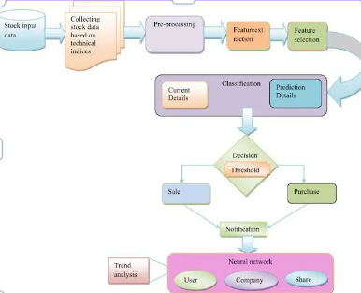

Figure 3.1 Flowchart

## Summary

The proposed system offers a comprehensive approach to stock market analysis and advisory, aiming to overcome the limitations of existing solutions. By incorporating advanced algorithms, leveraging external data sources, and prioritizing transparency, the system empowers users with more informed decision-making tools for navigating the complexities of the financial markets.

# CHAPTER 4

# SYSTEM DESIGN AND IMPLEMENTATION

## System Design and Implementation: A Foundational Approach

This section provides a comprehensive overview of the architectural design and development process undertaken for the stock market analysis and advisory system. It meticulously details the design and implementation of each module, outlining their core functionalities and critical components.

The system design and implementation phase serves as the bedrock of the stock market analysis and advisory system. Here, we prioritize the meticulous construction of individual modules that, when seamlessly integrated, will culminate in a robust and comprehensive platform. Each module is meticulously crafted to address specific facets of the investment process, ultimately leading to the generation of personalized and well-informed recommendations for investors.



Figure. 4.1 Example on how the bot sends notification

## Data Acquisition and Preprocessing

Module 1 constitutes the system's foundational pillar, encompassing the critical functions of data collection, preprocessing, and feature extraction.

* + - Data Collection: This stage meticulously gathers relevant stock market data from a multitude of sources. This data encompasses historical price information, trading volume data, and company financial statements.
    - Data Preprocessing: Raw data often exhibits inconsistencies and requires meticulous cleaning. This step addresses these issues by employing robust techniques to eliminate outliers, handle missing values, and normalize the data for subsequent analysis.
    - Feature Extraction: From the preprocessed data, this stage extracts pertinent features that will be utilized for in-depth analysis. Examples include moving averages, relative strength index (RSI), and other technical indicators that play a pivotal role in stock market analysis.

By meticulously collecting, cleaning, and extracting valuable features from the data, Module 1 lays the groundwork for accurate analysis and prediction in subsequent modules.

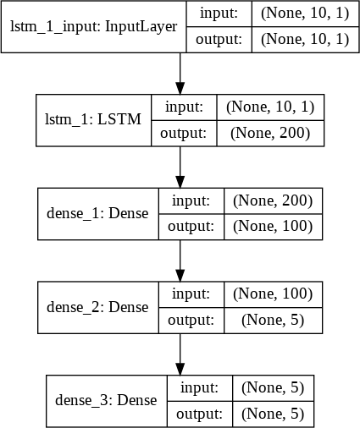

Figure 4.2 Flow Chart

## Leveraging Prediction Algorithms and Models

Module 2 focuses on the core of the system – the prediction engine. Here, we strategically leverage various algorithms and models to forecast stock prices.

* + - Algorithm Selection: This stage involves the critical selection of appropriate prediction algorithms. Factors such as system requirements and data characteristics will guide the selection of sophisticated algorithms like LSTM, Dense and Sequential or other advanced machine learning models.
    - Model Training: The chosen models are then meticulously trained using the historical stock market data. This rigorous training process enables the models to effectively learn the underlying patterns and trends within the data, which will be crucial for future price predictions.
    - Model Evaluation: To ensure the effectiveness of the trained models, we employ industry-standard performance metrics such as mean squared error (MSE) or accuracy. This rigorous evaluation process helps us gauge the models' ability to accurately predict stock prices.

By meticulously selecting, training, and evaluating prediction models, Module 2 equips the system with the capability to forecast future stock prices, paving the way for informed investment recommendations.

## Development of the Advisory System

Module 3 translates the analysis and predictions from Modules 1 and 2 into actionable insights for investors. This module forms the crux of the advisory component.

Recommendation Generation: Based on the predicted stock prices and identified market trends, this stage generates tailored buy, sell, or hold recommendations for investors.

* + - Risk Analysis: To guide investors towards well-rounded decisions, this stage incorporates a comprehensive risk analysis. This involves meticulously assessing the potential risks associated with each investment recommendation.
    - Investor Profile: To personalize the recommendations, Module 3 incorporates the creation and maintenance of individual investor profiles. These profiles capture factors such as risk tolerance and investment preferences, allowing the system to tailor recommendations to each investor's unique financial goals.

Through the generation of personalized recommendations, comprehensive risk analysis, and investor profile management, Module 3 empowers investors with a robust decision-making framework.

Datasets:

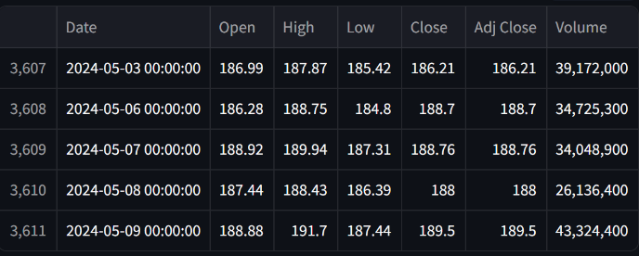

Figure4.3 Dataset of TESLA

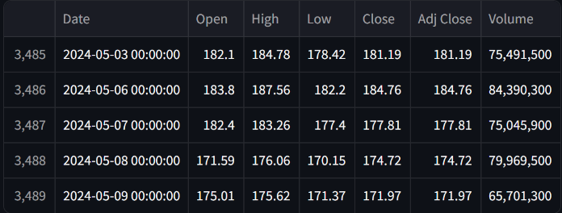

Figure 4.4 Dataset of AMZN

Technical Objective:

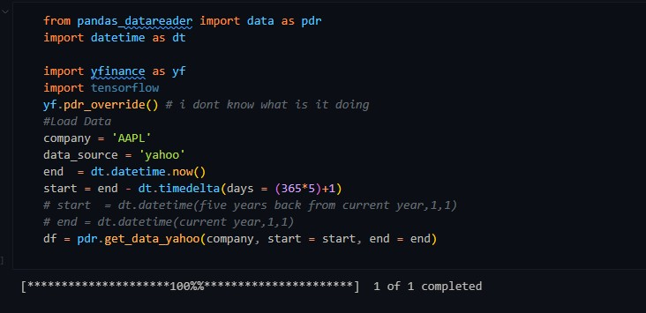

Figure 4.5 Code Snippet

**Long Short-Term Memory:** (LSTM) Long Short-Term Memory (or) LSTMs are widely used for sequence prediction problems and have proven to be extremely effective. The reason they work so well is because LSTM is able to store past information that is important and forget the information that is not.

LSTM has three types of gates:

1. The input gate: The input gate adds information to the cell state.
2. The forget gate: It removes the information that is no longer required by the model.
3. The output gate: Output Gate at LSTM selects the information to be shown as output. Training was done under the following metrics and functions:

* Number of layers = 4
* Loss Function= Mean Square Error
* Optimizer = Adam
* Epochs = 100
* Batch size = 64

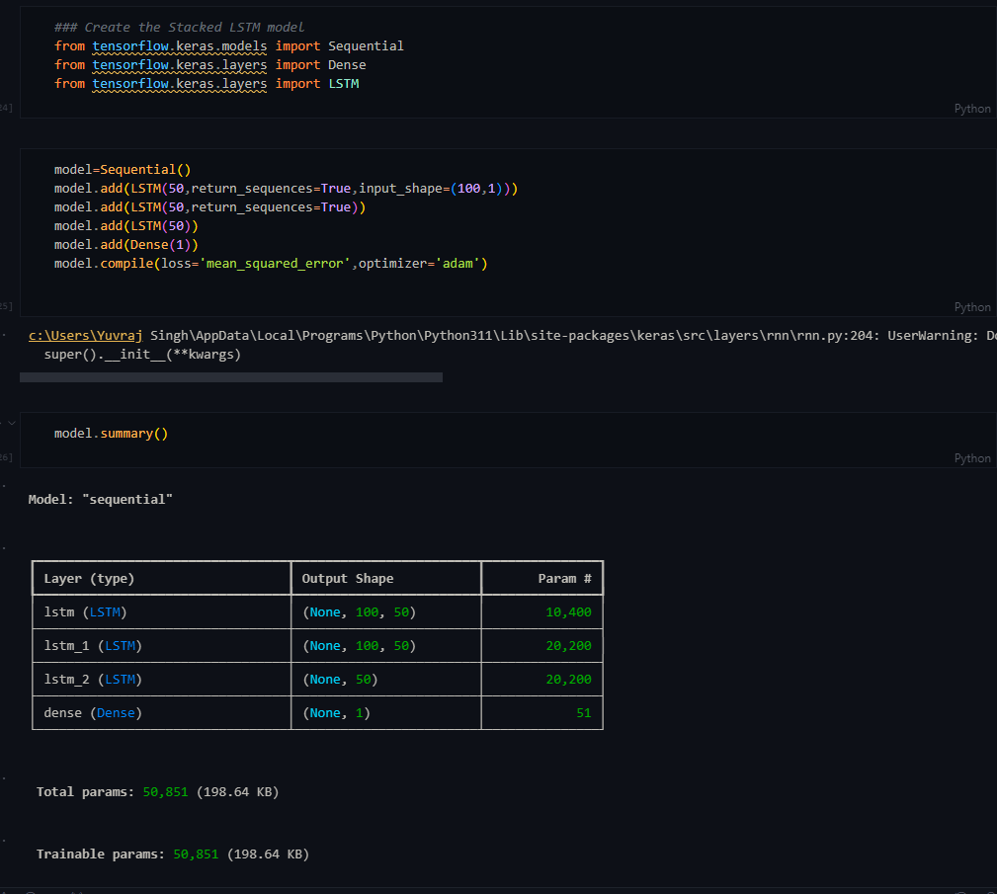

Figure 4.6 - Code Snippet

## Summary

The system design and implementation phase meticulously constructs a robust system for stock market analysis and advisory services. Each module, from data acquisition and preprocessing to prediction and advisory services, plays a vital role in the system's functionality. By integrating these modules, the system gains the capability to deliver accurate and reliable recommendations, ultimately assisting investors in making informed investment decisions.

# CHAPTER 5

# RESULT AND DISCUSSION

## 5.1 Introduction

The "Stock Market Analysis & Advisory" system represents a sophisticated platform tailored to empower investors with comprehensive insights into the dynamic world of stock trading. This introduction sets the stage for understanding the intricacies of its design and implementation. At its core, the system embodies a fusion of cutting-edge methodologies, including fundamental analysis, technical analysis, and sentiment analysis. Through meticulous examination of companies' financial health, historical price data, and market sentiment, the system aims to equip users with the tools necessary to make informed investment decisions. Its design emphasizes not only functionality but also user accessibility, ensuring that investors of all backgrounds can leverage its capabilities effectively. The implementation of this system entails harnessing advanced programming languages, data processing techniques, and cloud infrastructure to deliver real-time analysis and actionable insights. As such, the system design and implementation converge to create a robust platform poised to navigate the complexities of the stock market landscape.

Stock values are very valuable but extremely hard to predict correctly for any human being on their own. This project seeks to solve the problem of Stock Prices Prediction by utilizing Deep Learning models, Long-Short Term Memory (LSTM) Neural Network algorithms, to predict future stock values. This can be considered as a Time series analysis is a specialized branch of statistics used extensively in fields such as Econometrics & Operation Research. This is a specifically designed time series problem for you and the challenge is to forecast traffic.

In the past decades, there is an increasing interest in predicting markets among economists, policymakers, academics and market makers. The objective of the proposed work is to study and improve the supervised learning algorithms to predict the stock price.

The technical objectives will be implemented in Python. The system must be able to access a list of historical prices. It must calculate the estimated price of stock based on the historical data for the next 30 days. It must also provide an instantaneous visualization of the market index in a neatly formatted Python-Based Web App.

**Output-**

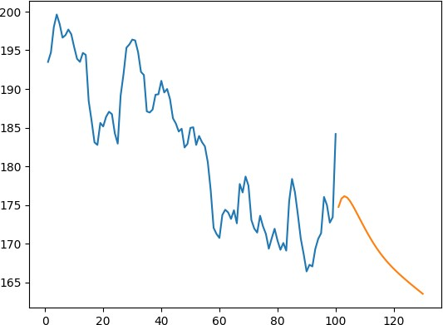

Figure 5.1 Predicted Graph For Next 30 Days

Blue - Stock Open values

Orange - Predicted Stock Open Values

## Conclusion:

The proposed Stock Price Predictor has been successfully trained by using the LSTM learning model on the sample datasets and the Stock value prediction process has been successfully performed by the trained LSTM model being tested on the test data set.

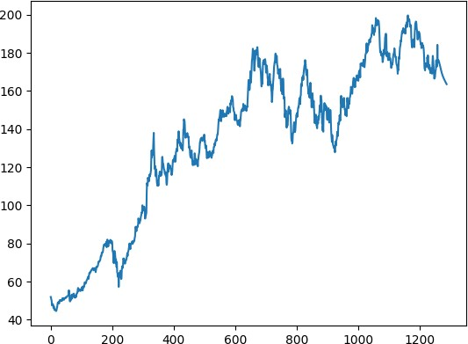

Figure 5.2 Full Dataset + Predicted Values

**Accuracy-**

|  |  |
| --- | --- |
| Actual value | 184.2 |
| Predicted value | 182.55 |
| Difference | 1.7 |
| Error percentage | 0.00975 |
|  |  |

Error Percentage = Predicted-Actual/Actual * 100

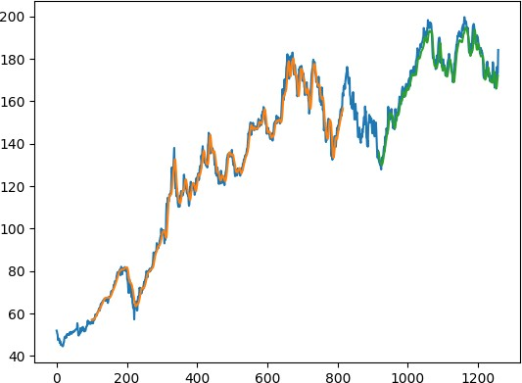

Figure 5.3 Accuracy Graph

Blue line - Actual Data

Orange line - Predicted Data in case of test data Green Line - Predicted Data

The orange line is the prediction data while training for the stock of the company while the blue line is the actual stock opening price for the specified company and the green line is the next 30 days predictions and and the blue lines over it are the actual stock open values on those days.

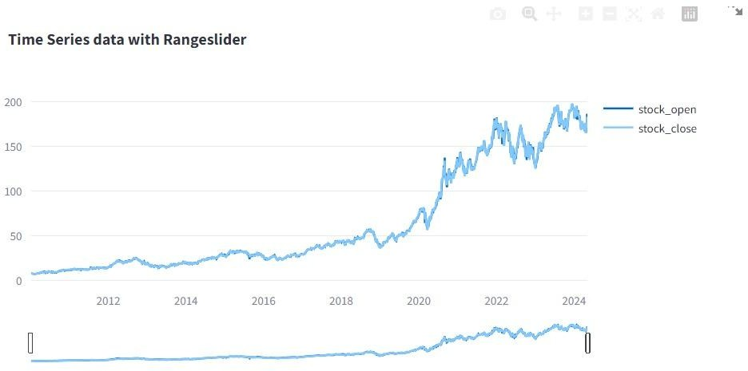

Figure 5.4 Time Series Data with Rangeslider

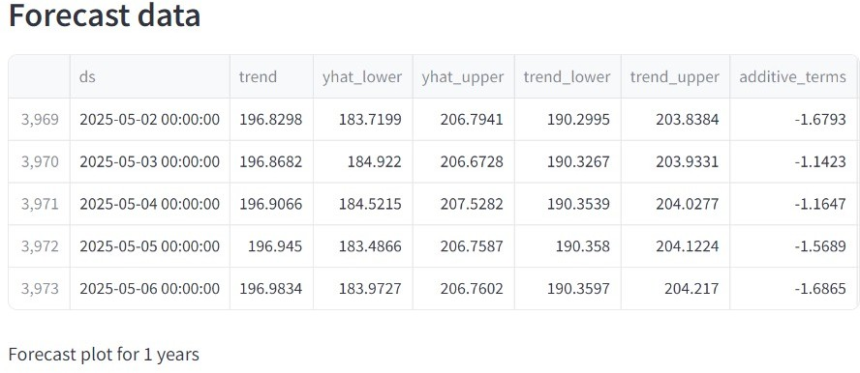

Figure 5.5 Forecast Data

# CHAPTER 6

# CONCLUSION AND FUTURE ENHANCEMENT

## Conclusion

In conclusion, the utilization of LSTM neural networks for stock analysis, coupled with a

user-friendly frontend GUI, offers a powerful tool for both investors and traders. By leveraging LSTM's ability to capture temporal dependencies in sequential data, the model can effectively learn patterns and trends in historical stock prices, enabling it to make informed predictions about future price movements.

However, it's essential to recognize the limitations of such models, including the inherent uncertainty and volatility of financial markets. While LSTM-based approaches can provide valuable insights, they should be used as one of several tools in a comprehensive investment strategy, taking into account other factors such as fundamental analysis, market sentiment, and risk management techniques.

Overall, the combination of LSTM-based stock analysis and a frontend GUI offers a promising avenue for enhancing decision-making processes in the financial domain, empowering users with actionable insights and facilitating more informed investment decisions.

## Future Enhancement

* + - Ensemble Models: Combine LSTM with other types of models such as Convolutional Neural Networks (CNNs) or Transformer-based models for improved performance and robustness.
    - Attention Mechanisms: Integrate attention mechanisms into LSTM networks to allow the model to focus on important time steps or features, potentially improving interpretability and performance.
    - Hyperparameter Optimization: Utilize techniques such as Bayesian optimization or genetic algorithms to automatically search for optimal hyperparameters for the LSTM model, leading to better performance.
    - Feature Engineering: Explore additional features such as technical indicators, sentiment analysis of news articles, or macroeconomic factors to enhance the predictive power of the model.
    - Data Augmentation: Apply data augmentation techniques to increase the diversity of the training data and improve the model's generalization ability.
    - Regularization Techniques: Incorporate regularization techniques such as dropout or batch normalization to prevent overfitting and improve the model's ability to generalize to unseen data

## 6.3 Limitation/Constraints of the system

While LSTM (Long Short-Term Memory) algorithms are powerful tools for time series prediction, particularly in the realm of stock market forecasting, they do come with several limitations and constraints:

* + - Data Dependence: LSTM models heavily rely on historical data for making predictions. As such, they may struggle to perform well in situations where past data is not a reliable indicator of future trends, such as during unprecedented events or major market shifts.
    - Overfitting: LSTM models can easily overfit to the training data, especially when dealing with noisy or limited datasets. This can lead to poor generalization and inaccurate predictions on unseen data.
    - Limited Interpretability: While LSTM models are effective at capturing complex patterns in data, they are often seen as "black box" models, making it difficult to interpret the rationale behind specific predictions. This lack of transparency can be a significant constraint, especially in industries where interpretability is crucial.
    - Sensitivity to Hyperparameters: LSTM models contain several hyperparameters (e.g., number of layers, number of neurons, learning rate) that need to be carefully tuned for optimal performance. Finding the right combination of hyperparameters can be

time-consuming and may require significant computational resources.

* + - Data Preprocessing Requirements: LSTM models typically require preprocessing steps such as normalization, scaling, and feature engineering to ensure optimal performance. This can add complexity to the model development process and may introduce additional sources of error if not done properly.
    - Limited Short-Term Accuracy: While LSTM models are capable of capturing long-term trends in stock prices, they may struggle to accurately predict short-term fluctuations or sudden market movements. Factors such as market sentiment, news events, and external shocks can significantly impact short-term stock prices and may not be fully captured by the model.

# REFERENCES

[1] Shreya Pawaskar “Stock price prediction using Machine learning algorithms” June18 2019

[2] L. Mathanprasad and M. Gunasekaran, "Analysing the Trend of Stock Marketand Evaluate the performance of Market Prediction using Machine Learning Approach," 2022 International Conference on Advances in Computing, Communication and Applied Informatics (ACCAI), Chennai, India, 2022

[3] K. Pahwa and N. Agarwal, "Stock Market Analysis using Supervised Machine Learning," 2019 International Conference on Machine Learning, Big Data, Cloud and Parallel Computing (COMITCon), Faridabad, India, 2019

[4] H. Bourezk, A. Raji, N. Acha and H. Barka, "Analyzing Moroccan Stock Market using Machine Learning and Sentiment Analysis," 2020 1st International Conference on Innovative Research in Applied Science, Engineering and Technology (IRASET), Meknes, Morocco, 2020

[5] Kumar, K. Dogra, C. Utreja and P. Yadav, "A Comparative Study of Supervised Machine Learning Algorithms for Stock Market Trend Prediction," 2018

[6] S. Ravikumar and P. Saraf, "Prediction of Stock Prices using Machine Learning (Regression, Classification) Algorithms," 2020

[7] L. Kotapati, R. B. Sajjala, S. Gudi, B. V. N. Hareesh, S. Tokala and M. K. Enduri, "Forecasting Stock Markets Trends using Machine Learning Algorithms," 2023

[8] J. Guntaka, V. J. Karunakar Reddy Gade, R. Yallavula, A. D. Kumar and P. V. Sagar, "Stock Market Prediction using Machine Learning Technique," 2023

[9] S. Khunti, P. Kumar, M. L. Rao, T. V. Muni, V. S. Singh and S. C. M. Subhani, "Application of Machine Learning and Deep Learning Algorithms to the Prediction of Stock Market Trends," 2023

[10] R. Sable, S. Goel and P. Chatterjee, "Empirical Study on Stock Market Prediction Using Machine Learning," 2019